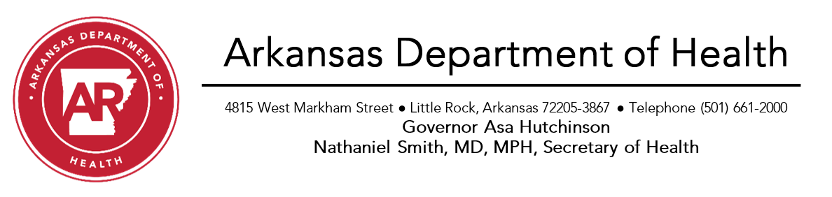
Effective: June 1, 2020

Directive for Community and School Sponsored Team Sports
The Secretary of Health, in consultation with the Governor, has sole authority over all instances of quarantine, isolation, and restrictions on commerce and travel throughout Arkansas, as necessary and appropriate to control disease in the state of Arkansas as authorized by Ark. Code Ann. §20-7-109--110. Based on available scientific evidence, it is necessary and appropriate to take further action to ensure that COVID-19 remains controlled and that residents and visitors in Arkansas remain safe.
On March 26, 2020, the Secretary of Health in consultation with the Governor placed limitations on public gatherings. This directive provides requirements for lifting limitations to community based and school sponsored team sports through a phased approach for all ages of athletes. Each phase has a set of General Requirements that apply across all team sports with specific requirements applied based on the nature of the contact required by the rules or conditions of the sport.
This directive does not include intercollegiate athletic team sports. This directive allows bands to practice marching and the use of non-wind instruments. However, due to the potential for increased production of respiratory droplets in wind instruments, they should not be used at this time.
General Requirements
- Maintain minimum physical distancing of six feet between participants at all times, except when actively participating in the sports activity.
- Athletes, Coaches, and All Staff must be screened prior to any activity by asking the following questions and excluded if the answer is yes.
  - Have had a fever of 100.4°F or greater in the last 2 days
  - Have a cough, difficulty breathing, sore throat, or loss of taste or smell
  - Had contact with a person known to be infected with COVID-19 within the previous 14 days
- Coaches and All Staff must have temperature checked by digital thermometer prior to entry, and those whose temperature is greater than 100.4°F must be excluded.
- Face coverings that completely cover the nose and mouth are required for everyone 10 years of age or older.
  - Athletes
    - Must wear a face covering when not actively participating in the sports activity.
    - Face coverings or masks must be worn in sports where a face covering is not inhibitory.
  - Coaches and Staff
    - Must wear a face covering at all times.
- Use of communal spas, showers, saunas or other similar equipment are prohibited. Locker rooms may only be used for storage of personal items. Social distancing of 6 feet must be maintained in the locker room.
- An alcohol-based hand sanitizer or adequate handwashing facilities must be provided for use by all attendees.
- Sports equipment, restrooms, lockers, water fountains and other high touch surfaces must be sanitized frequently during each event. For a list of cleaning products that will eliminate the Covid-19 virus, visit https://www.epa.gov/pesticide-registration/list-n-disinfectants-use-against-sars-cov-2.
- Avoid non-sport related personal contact at all times. This includes, but is not limited to, huddles, high-fives, hand shaking, fist bumping, and chest bumping.
- For games, competitions, tournaments, meets, and other athletic events held in a facility, the facility hosting the event must follow the current Directive for Large Indoor or Large Outdoor Venues. Spectators are covered under these Directives.
- For training and conditioning held in an athletic facility, the facility must follow the current Directive for Gym, Fitness Center, Athletic Club and Weight Rooms.
- Concession Stands may operate but must follow all applicable sections of the Directive for Resuming Restaurant Dine-In Operations.
- Admission and gate ticket sales should be taken online when possible.
Close-Contact Team Sports
Example: Basketball, Wrestling, Football, Cheerleading, Dance, Volleyball, Soccer, Martial Arts
- Team practice and/or competition is prohibited due to the close personal contact that is required or anticipated. Individual practice is permitted.
  - Cheerleading and Dance may practice under the Directive for Gym, Fitness Center, Athletic Club and Weight Rooms.
- Conditioning and training may occur if the following conditions are implemented, in addition to the General Requirements:
  - Group size must be sufficiently limited to maintain 6 feet between each person, including staff, whenever in an indoor or outdoor enclosed space.
  - When using weight rooms, practicing calisthenics, running, or other conditioning training where vigorous exercise occurs, must maintain proper spacing from others by working out with 12 feet between each person. This may require closing or moving some equipment.
  - Spotters are allowed on the outside of weight bars on each side, for safety reasons. Physical distancing must be maintained when not actively performing spotting duties.

- Individual practice participants should use their own equipment, if possible.

Limited-Contact Team Sports
Examples: Baseball, Softball, Golf, Track and Field, Cross Country, Bowling, Tennis, Gymnastics, Shooting Sports, Swimming, Individual Dance Competitions
- Competition is allowed for participants of any age. However, participants should refrain from competition if:
  - They are 65 years of age or older.
  - They have underlying health conditions including high blood pressure, chronic lung disease, diabetes, severe obesity, asthma or weakened immunity
- Practice for all ages may be permitted if the following conditions are implemented:
  - Player group size must be sufficiently limited to maintain 6 feet between each person, including staff, whenever possible.
  - When using weight rooms, calisthenics, or other conditioning training must maintain proper spacing from others by working out with 12 feet between each person. (This may require closing or moving some equipment).
- When appropriate, participants should provide their own equipment, if possible. If shared equipment is used, disinfection is required frequently during each event or between each use.

ADH will continue to closely monitor the evolving novel coronavirus (COVID-19) outbreak. These measures will remain in place until data on the severity of the local COVID-19 epidemic indicate it is safe to further relax measures. This Directive will be reevaluated on June 30, 2020.
Resources
- https://www.cdc.gov/coronavirus/2019-nCoV/index.html
- https://uamshealth.com/coronavirus/kb/expert-recommendations-and-considerations-for-high-school-athletics/
- https://www.aspenprojectplay.org/coronavirus-and-youth-sports
- https://wagolf.org/wp-content/uploads/2020/04/Golfing-Restart-Requirements_Final.pdf
- https://www.thengfq.com/2020/05/protecting-golfers-and-course-staff-amid-coronavirus-outbreak/
- https://www.epa.gov/pesticide-registration/list-n-disinfectants-use-against-sars-cov-2

